

ISLAMIC UNIVERSITY OF TECHNOLOGY (IUT)
ORGANISATION OF ISLAMIC COOPERATION (OIC)
Department of Computer Science and Engineering (CSE)

QUIZ 4 STATISTICS

Average Breakdown

Problem |  | Avg | Out of | Percentage (%) | Avg | Out of | Percentage (%)
FF conversion | Detect FF | 1.27 | 3 | 42.28 | 5.56 | 10 | 55.61
 | Reasoning | 4.29 | 7 | 61.32
Register | Diagram | 3.15 | 5 | 62.93 | 5.59 | 10 | 55.85
 | Logic | 2.44 | 5 | 48.78
Total |  | 11.15 | 20 | 55.73 | 11.15 | 20 | 55.73

Attempts
Problem |  | Attempts | Out of | Percentage (%)
FF Converter | Detect FF | 23 | 41 | 56.10
 | Reasoning | 41 |  | 100.00
Register | Diagram | 34 |  | 82.93
 | Logic | 29 |  | 70.73

Full Marks

Problem |  | Full | Out of | Percentage (%)
FF Converter | Detect FF | 12 | 41 | 29.27
 | Reasoning | 7 |  | 17.07
Register | Diagram | 9 |  | 21.95
 | Logic | 9 |  | 21.95

Performance Graph

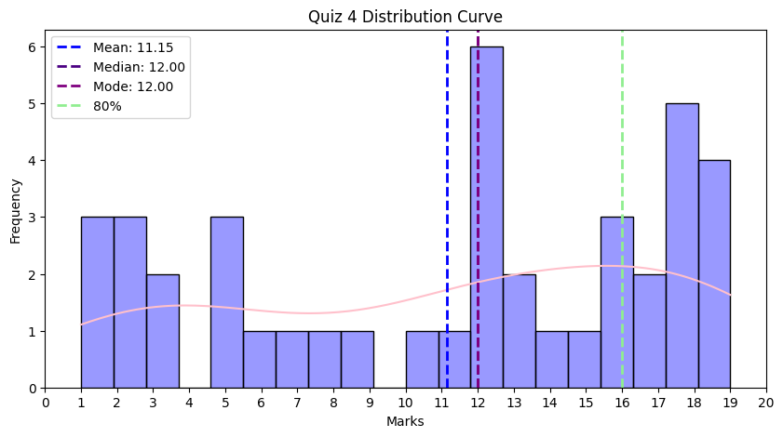

Leaderboard

Sl | ID | Name | Marks
1 | 230042141 | Ayman Binta Altaf Nondiny | 20
2 | 230042111 | Md. Ashraful Abedin | 19
3 | 230042134 | S. M. Raiyan Al Arafat | 19
4 | 230042125 | Ittesaf Yeasir Ithun | 18.5
5 | 230042104 | S.m. Tahsinuzzaman Emon | 18
6 | 230042129 | Hasan Mobarak Mahi | 18
7 | 230042133 | Tamim Mahrush Naser | 18
8 | 230042143 | Wasi Omar Syed | 18

Unnecessary Statistics
- Only 41 students participated in the quiz (lowest attendance among all quizzes).
- Even after a fair warning, one student did not write down his ID on the answer script. As mentioned before his marks should have been distributed among a few students, however the marks obtained by that specific student was 1, so that makes it invalid.
- The average of the 4th quiz was the lowest among all other quizzes.
- Bonus – No more bonus attendance since it has become meaningless at this point.

